Ideation Phase

Brainstorm & Idea Prioritization Template

Date | 31 jan 2026
Team ID | LTVIP2026TMIDS37875
Project Name | Heart Disease Analysis
Maximum Marks | 4 Marks
Brainstorm & Idea Prioritization Template:

Introduction to Brainstorming Process
The ideation phase was conducted to identify a meaningful problem statement and to develop a data-driven solution through collaborative thinking. Brainstorming sessions created an open environment where all team members contributed ideas based on their academic knowledge, domain interest, and awareness of real-world challenges.

Step 1 – Team Gathering, Collaboration and Problem Statement Selection
All team members actively participated in structured discussion sessions to identify potential project domains such as healthcare analytics, financial analytics, education analytics, and social media analysis.

Each proposed idea was evaluated using the following criteria:

Real-world relevance Availability of authentic dataset
Scope for data preprocessing and visualization Technical feasibility using the available tools Ability to generate meaningful insights

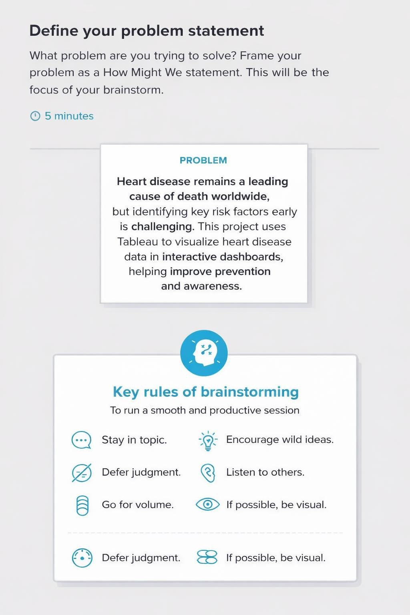

Step-2: Brainstorm, Idea Listing and Grouping

uring this stage, all team members contributed ideas which were listed without criticism to encourage creativity. The ideas were then grouped based on similarity and relevance.

3.1 Initial Idea List
Predicting heart disease based on patient health parameters Identifying lifestyle factors affecting heart disease Regional analysis of heart disease cases
Comparing heart disease risk across age groups and gender Analyzing the impact of diabetes, obesity, and smoking Building an interactive healthcare dashboard
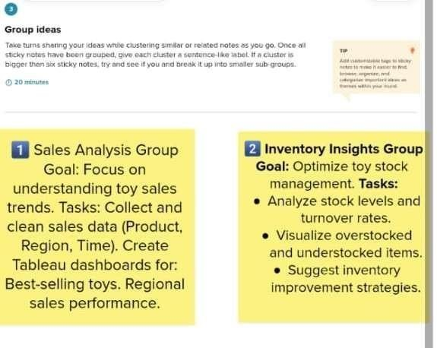
Creating a web-based interface for visualization access

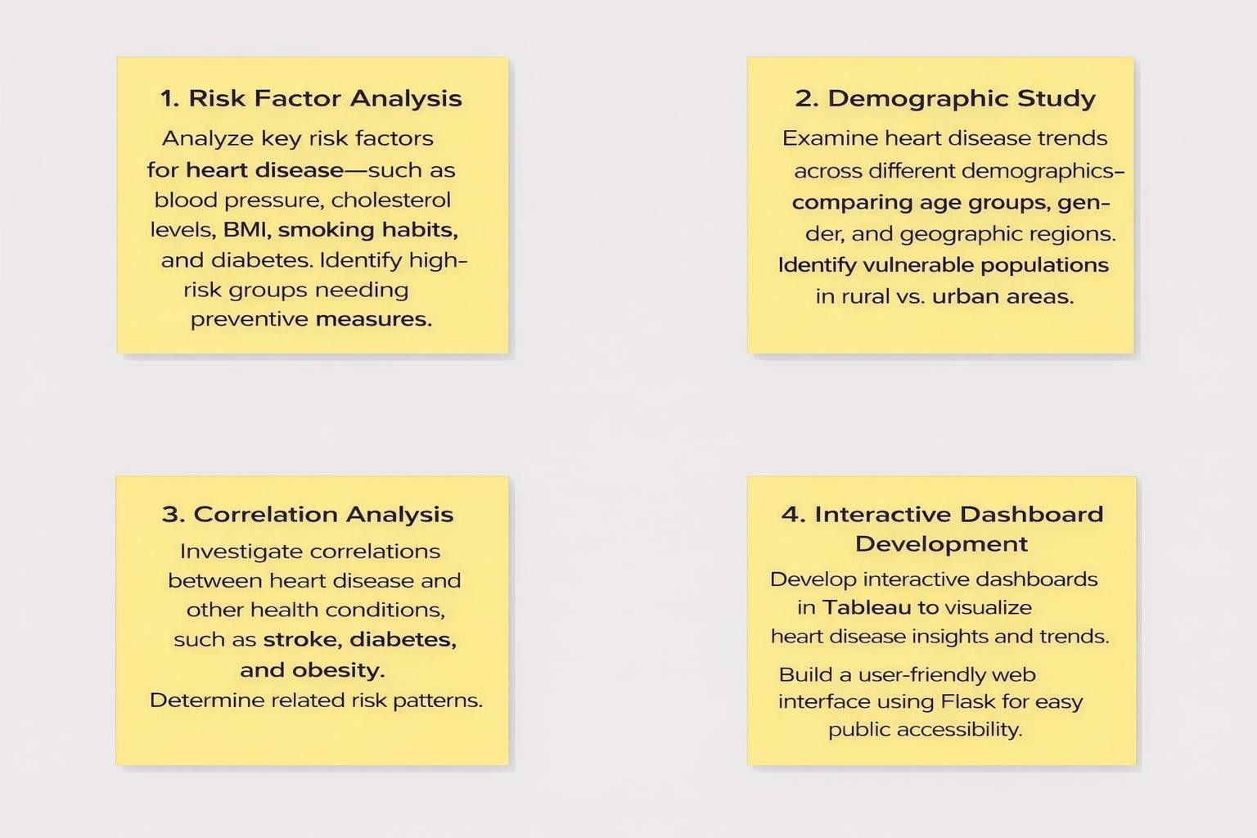

Step-3: Idea Prioritization

After grouping, the ideas were prioritized based on: Analytical depth
Visualization potential Data availability Implementation complexity
Academic evaluation requirements The final project scope was defined as:
Performing data preparation using SQL

Developing multiple analytical visualizations in Tableau Creating an interactive dashboard to highlight key health insights
Integrating the dashboard with a Flask web application for accessibility

